

Dr. A. Q. Khan Institute of Computer Science and
Information Technology
Department of Computer Engineering

LAB REPORT
Computer Architecture (Lab)

Submitted To
Madam Muneeba Mubarak

Submitted By
Muhammad Saleh Hayat

Roll No:
232201070

BSCS- V-B

Lab Rubrics:
Lab Report | Coding | Logic | Total
4 | 4 | 4 | 12

Counter

A counter is a sequential digital circuit that counts clock pulses and stores the result in binary form.
It is implemented using flip-flops and operates with a clock signal.

Uses of Counters
- Program Counter (PC)
- Instruction cycle counting
- Timing and control circuits
- Memory addressing
- Clock division

Why D Flip-Flop Is Used in Counters

D Flip-Flop is preferred because its operation is simple and reliable.

Rule:
Q(next) = D
The value at input D appears at output Q on the next clock edge.
Due to this property, D Flip-Flops are widely used in practical hardware.

D Flip-Flop Truth Table
D | Q(next)
0 | 0
1 | 1

4-Bit Binary Up Counter (State Table)

Clock ↑ | Reset | Present State | Next State
↑ | 1 | XXXX | 0000
↑ | 0 | 0000 | 0001
↑ | 0 | 0001 | 0010
↑ | 0 | 0010 | 0011
↑ | 0 | 0011 | 0100
↑ | 0 | 0100 | 0101
↑ | 0 | 0101 | 0110
↑ | 0 | 0110 | 0111
↑ | 0 | 0111 | 1000
↑ | 0 | 1000 | 1001
↑ | 0 | 1001 | 1010
↑ | 0 | 1010 | 1011
↑ | 0 | 1011 | 1100
↑ | 0 | 1100 | 1101
↑ | 0 | 1101 | 1110
↑ | 0 | 1110 | 1111
↑ | 0 | 1111 | 0000

Design of a Counter Using D Flip-Flops in Verilog:
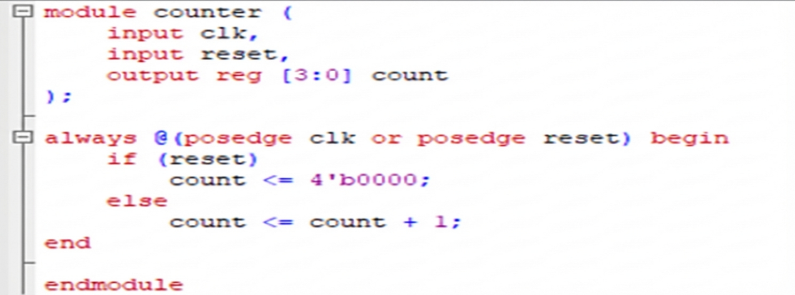
Simulation of Counter Using D Flip-Flops in Verilog:
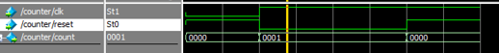
Implementation of Counter Using D Flip-Flops using Testbench
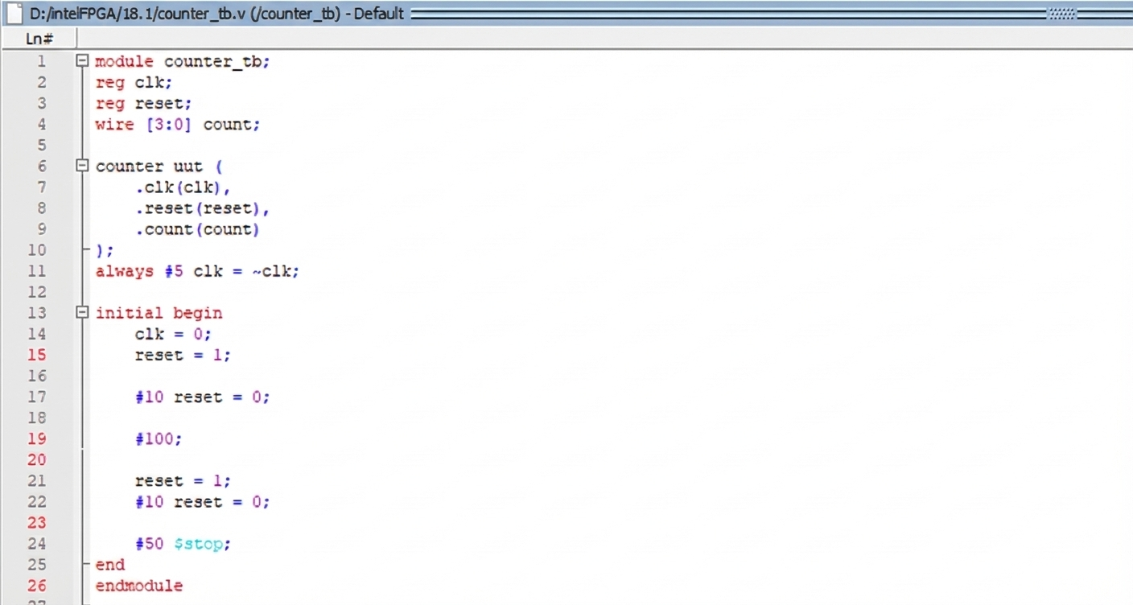
Simulation of Counter Using D Flip-Flops using Testbench:
